FOR GENERAL KNOWLEDGE, ETUC HAS RECOGNIZED:

ETUC KEEPS ON BACKING THE BOURGEOISIE
IN THE IDEOLOGICAL STRUGGLE AND
IN THE ATTACKS AGAINST WORKERS' RIGHTS.

Recently, ETUC has published in its documents, under the title: "the fall of Communism (and of fascism)", sentences like this one, literally transcribed: "the Solidarnosc trade union played an important role in the fall of Communism in Poland and inspired the opposition to Communism in other Eastern European countries".
We must be grateful for having written it so outspokenly; they financed Solidarnosc and indeed they know it well though, as usual, they started lying about the role of Lech Walessa and his followers.
Some of the readers of my comments won't be surprised; ETUC, at European level, and ITUC, at an international one, have always been helping the bourgeoisie; but sometimes they've tried to conceal it by pretending they defend the workers.
They themselves confirm by the above quotation that all the millions of $ and € they are granted with are due to their defence of capitalism.
This explains, as the adjoined photo shows, why IMF (International Monetary Fund) top leader considers ITUC secretary as a close friend which deserves public effusive hugs as a reward for her support to monopoly capital (which is the boss of IMF).
The class based trade unions worldwide must unmask these trade unions which constantly betray the working class, signing with the bosses and the capitalist governments destructions of social gains which took years to achieve. An example in Spain is the acceptance by CCOO & UGT of the postponement of the retirement age to 67 (with a 30% loss in the pensions); conversely, in other countries such as Bolivia, the TU, affiliated to the WFTU (world federation of trade-unions) signed the reduction of the retirement age to 58 for men and 55 for women (moreover lowered for them by 2 years for each child down to the age of 49).
There is a clear difference between yellow, reformist, class collaboration and social partnership trade unionism and class struggle based one.
Yellow trade unionism equate communism and fascism (so they write); but the working class experiences that under capitalism it is exploited and will always be. Its consciousness grows that getting rid of its exploitation by the bourgeoisie (which rules most countries) will only be possible through destroying capitalism and building Socialism.
We, trade unions unsold to capitalism, will keep on fighting until we change this state of human exploitation and slavery.

Quim Boix, CP, Presidential Council of WFTU, General Secretary of TUI of Pensioners and Retirees (P&R)

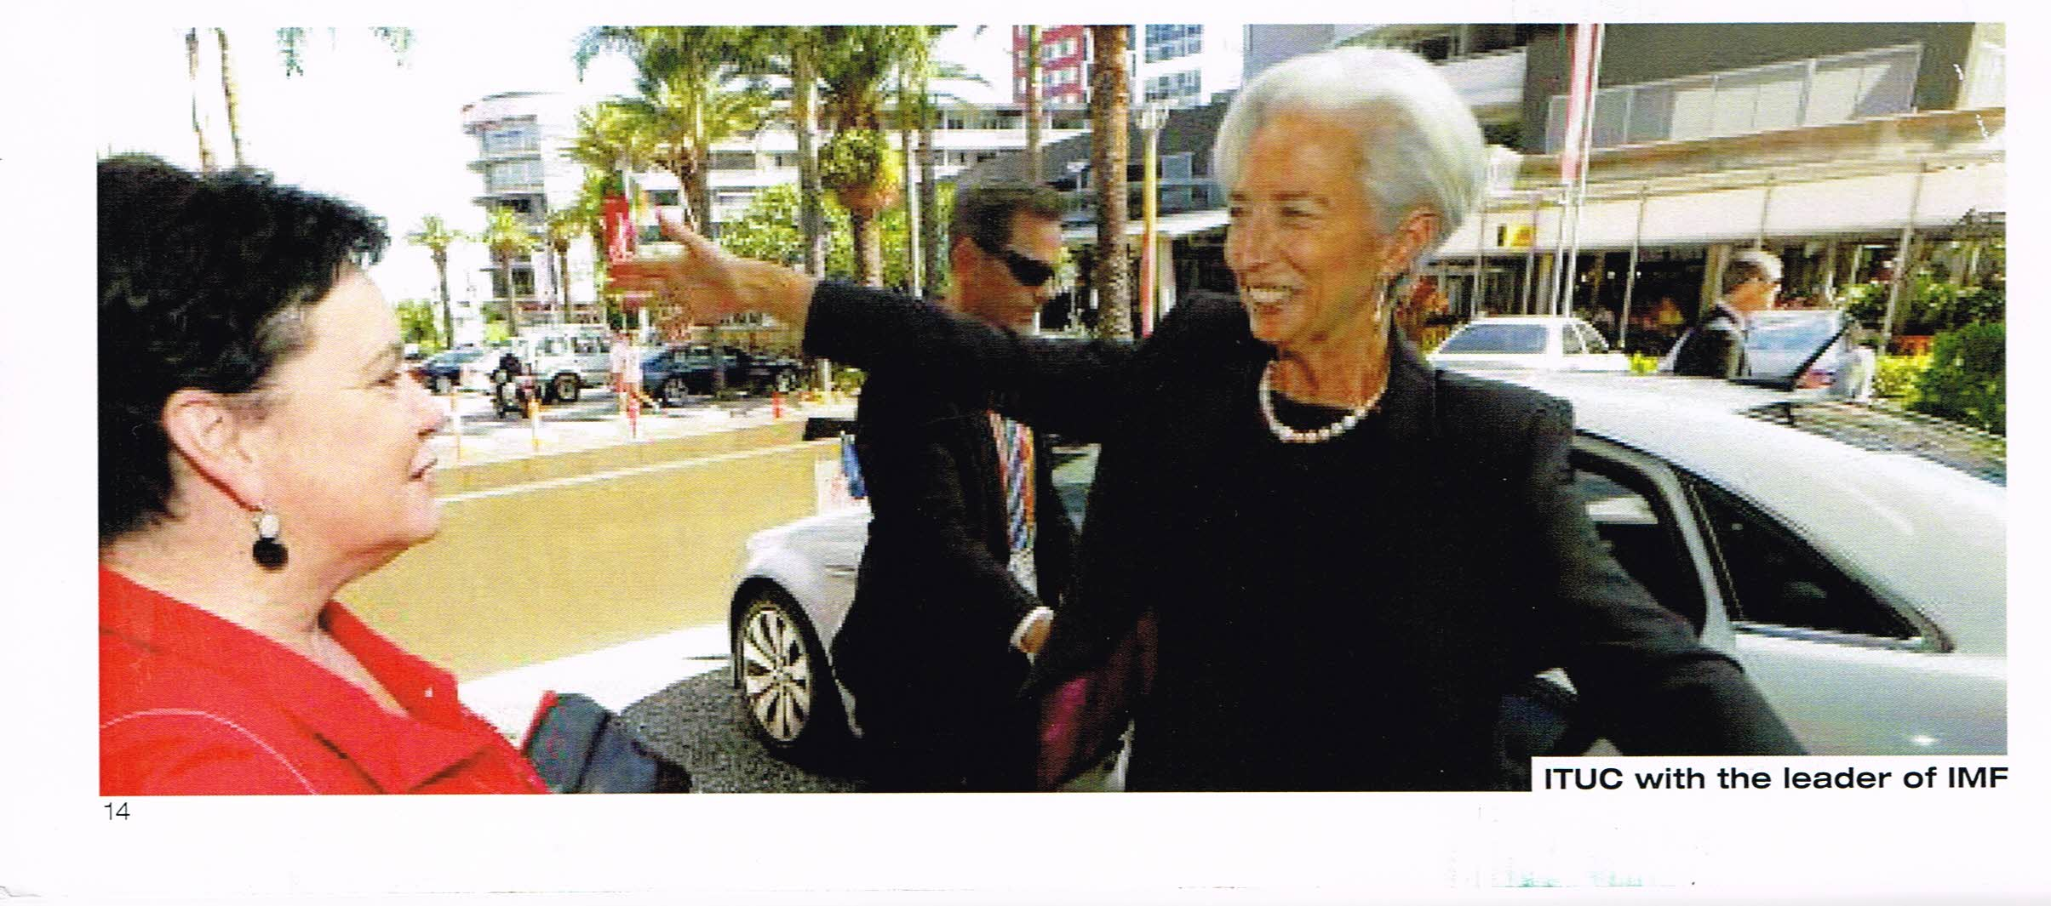
Sharan Burrow, ITUC General Secretary, and Christine Lagarde, leader of IMF

