WORLD FEDERATION OF TRADE UNIONS

The World Federation of Trade Unions (WFTU), which brings together almost 100 million workers affiliated to the trade unions of the five continents, wishes to denounce imperialism as the main responsible for the attacks in the world such as today in Barcelona (Spain).

No one would hate the Europeans if the EU (European Union) and the United States did not have the will to rob and steal the riches of the peoples, which capitalism can no longer practice as it did in the colonial era; If every day and every week there were not tens (sometimes hundreds and thousands) of people killed by NATO troops (and hardly appearing at the news); If the borders were not closed for the passage of citizens of the South who seek better economic conditions in the North (while fully open to the circulation of products that give business to multinationals).

The WFTU, which was born just after the end of World War II, knows that the working class has never wanted wars or attacks. The WFTU has repeatedly pronounced, since its creation for peace on the planet, the negotiated solution of conflicts, the dissolution of NATO, and the end of the plunder of countries in Africa, Asia and America by the Multinationals aided by the troops of imperialism.

As long as we do not end imperialism, the attacks will not end, as acts of hatred and rage of the massacred by the bombs that fall in many countries daily, decided from offices occupied by people who appear to be civilized but who are actually the biggest killers today.

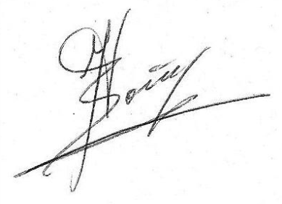
Barcelona, ​​on August 17, 2017
Quim Boix
Responsible of the WFTU in the Spanish State (except the Basque Country)

40, Zan Moreas street, Athens 11745 GREECE
Tel. +302109214417, +302109236700, Fax +30210 9214517
http://www.wftucentral.org E-mails : info@wftucentral.org, international@wftucentral.org

