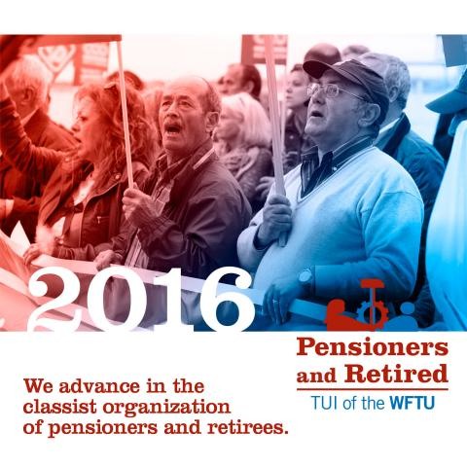

World organization of Pensioners and Retirees (P&R)
of the WFTU´s appeal.

To all the affiliated organizations that will take part on the actions of October 1st, 2016

WORLD´S STRUGGLE DAY OF P&R

The capitalist crisis and its barbarism are underway. Governments and capital are trying to find a temporary way out of the crisis placing its weight on the pensioners, retirees and popular layers.

In order to increase capitalist competitiveness, Pensioners and Retirees all over the world are suffering the worsening of their daily life conditions as well as those of their sons.

Their pensions are being reduced, public Health services are being placed on private hands, social structures are being destroyed, their rights are being greatly limited. In some many places this rights don´t exist.

The capitalist states along with the company owners are reducing its participation in social security putting all the expenses on workers and Retirees, so easing the way to a private social security. In many countries of the world there are not any kind of infrastructure, medical and pharmacy care, public pensions, proper housing or drinkable water.

We appeal to carry all kind of actions (demonstrations, concentrations, the issue of documents to the authorities, assemblies, conferences, etc.) to all our organizations of Pensioners and Retirees for the forthcoming October the first, International Day of Retirees.

We are fighting for:

1) The universal right for a pension.
2) To reduce the retirement age for men and much more for women.
3) Public and free of charges Social Security.
4) Public and free of charge medical and pharmacy assistance for everybody, without limitations and/or restrictions.
5) Public pensions enough to guarantee our current needs in order to have a dignified life (Social support, proper housing, fresh water, medical care, public, free and accessible means of transportation and leisure.

WE DO NOT ACCEPT THE CAPITALIST´S LEFTOVERS
WE FIGHT TO CONQUER A LIFE AND A FUTURE ACCORDING TO THE WEALTH WE PRODUCE
LONG LIFE UNIVERSAL SOLIDARITY!

LONG LIFE TO OCTOBER THE FIRST!



